Revenue Strategy & Pricing Strategy
MODULE V

1.Overview
This module transitions from historical reporting to forward-looking strategy. It focuses on maximizing Total Revenue (TRevPAR) by analysing ancillary revenue streams (Upselling), implementing a Dynamic Pricing Engine using "What-If" parameters, and creating role-specific dashboards for General Managers (GMs) and Revenue Managers (RMs).

2. Data Preparation
To support the Upsell Analytics, a new table was introduced to the model:
- Table Name: Ancillary_Transactions
- Purpose: Tracks non-room revenue streams such as Spa, Dining, Laundry, and Beverage services.
- Key Columns:
TransID, BookingID, ServiceType, Item, Quantity, Amount, Date.
- Relationship: Linked to the core Bookings table via BookingID to associate ancillary spend with specific guest stays.
- Go To Home Transform Data New Source Blank Query
- Name the table as “Ancillary_Transactions”
- Paste this M code and click on Close and apply

= let
// Load Bookings table (Assumes 'Bookings' is already a defined step or query)
Source = Bookings,

// Filter valid bookings
ValidBookings = Table.SelectRows(Source, each [CheckInDate] <> null and [CheckOutDate] <> null),

// Add ServiceType randomly by cycling through 6 options using modulus 6
WithServiceType = Table.AddColumn(ValidBookings, "ServiceType", each
let
r =Int8.From(Number.RandomBetween(0, 5))
in
if r = 0 then "Spa"
else if r = 1 then "Dining"
else if r = 2 then "Services"
else if r = 3 then "HouseKeeping"
else if r = 4 then "Beverage Service"
else "Pool"),

// Add Item based on the assigned ServiceType
WithItem = Table.AddColumn(WithServiceType, "Item", each
if [ServiceType] = "Spa" then "Swedish Massage"
else if [ServiceType] = "Dining" then "Buffet Dinner"
else if [ServiceType] = "Services" then "Airport Pickup"
else if [ServiceType] = "HouseKeeping" then "Laundry Service"
else if [ServiceType] = "Beverage Service" then "Drinks & Bar"
else "Poolside Breakfast"),

// Add Quantity randomly (1 to 3)
WithQuantity = Table.AddColumn(WithItem, "Quantity", each
1 + Number.Mod(Text.Length([CustomerID]) + Number.From(Date.Day([CheckInDate])), 6)),

// Add Amount based on ServiceType and Quantity
WithAmount = Table.AddColumn(WithQuantity, "Amount", each
let
// Define base prices for all six services
base = if [ServiceType] = "Spa" then 1800
else if [ServiceType] = "Dining" then 1200
else if [ServiceType] = "Services" then 1000
else if [ServiceType] = "HouseKeeping" then 500
else if [ServiceType] = "Beverage Service" then 300
else 800 // Base price for Poolside Cocktails
in
base * [Quantity]),

// Add Transaction Date within stay period
WithDate = Table.AddColumn(WithAmount, "Date", each
let los = Duration.Days([CheckOutDate] - [CheckInDate]),
offset = Number.Mod(Text.Length([RoomID]) + Number.From(Date.Day([CheckOutDate])), los + 1)
in Date.AddDays([CheckInDate], offset)),

// Add TransID
WithIndex = Table.AddIndexColumn(WithDate, "TransID", 1, 1, Int64.Type),
Final = Table.TransformColumns(WithIndex, {
{"TransID", each "ANC" & Text.PadStart(Text.From(_), 5, "0"), type text}
}),

// Select final columns
AncillaryTable = Table.SelectColumns(Final, {"TransID", "BookingID", "CustomerID", "Date", "ServiceType", "Item", "Quantity", "Amount"})
in
AncillaryTable

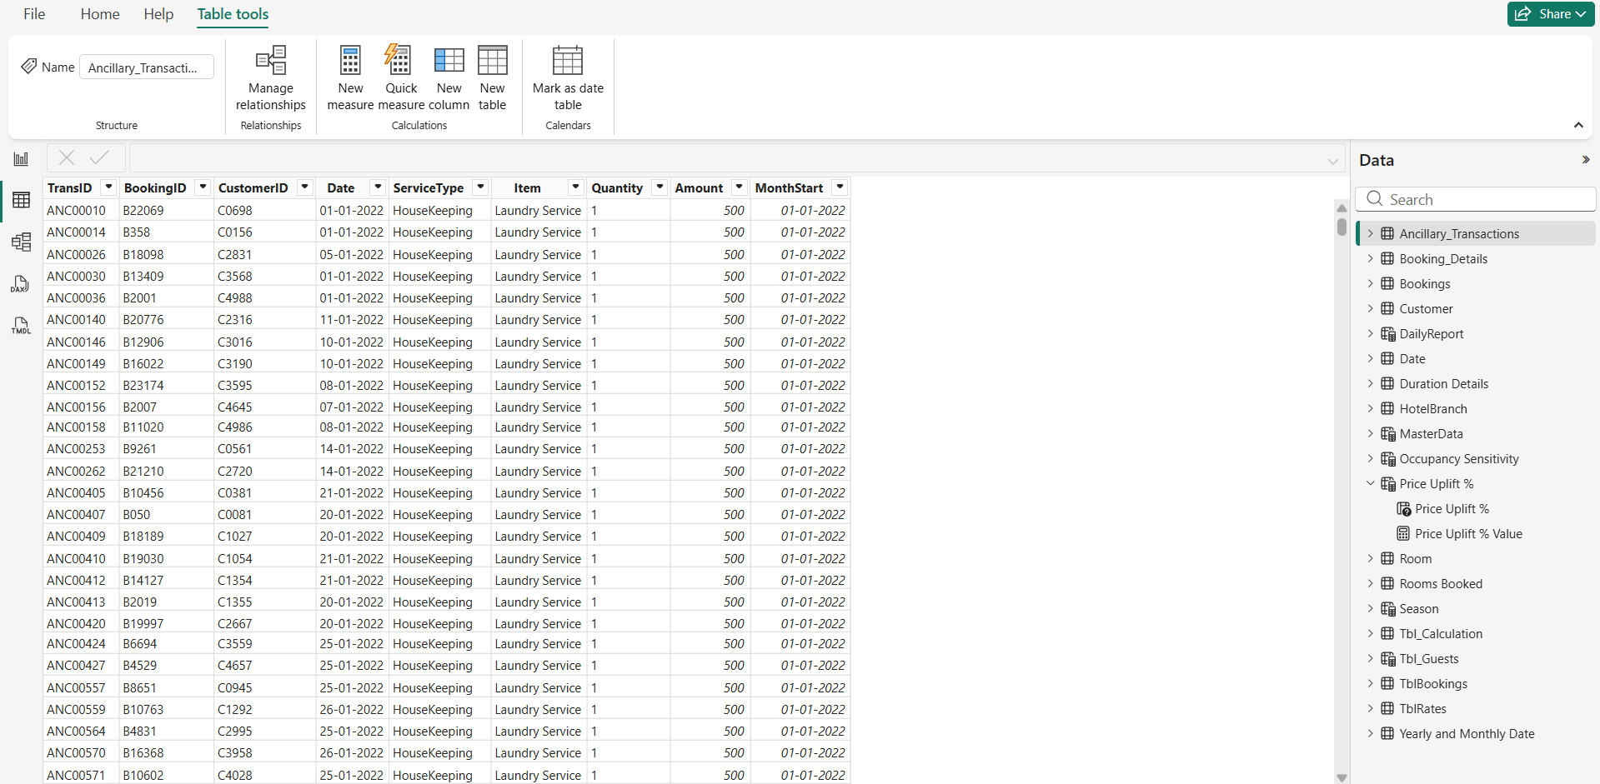

3. The Dynamic Pricing Engine
The core of this module is the Recommended Price measure, which calculates an optimal room rate based on three factors: Seasonality, Strategic Uplift, and Demand Elasticity.

"What-If" Parameter Configuration
Two interactive parameters were created to allow Revenue Managers to simulate different pricing scenarios without altering the underlying data.
1. Price Uplift %
Allows the manager to manually increase or decrease rates across the board based on market strategy.
- Location: Modeling → New Parameter → What-If Parameter
- Name: Price Uplift %
- Data Type: Decimal Number
- Min: -0.10 (-10%)
- Max: 0.20 (+20%)
- Increment: 0.01
- Default: 0
2. Occupancy Sensitivity
Models the "Elasticity" of demand. If demand is high (Sensitivity > 1), the system suggests higher rates. If the market is soft (Sensitivity < 1), it suggests lower rates.
- Location: Modeling → New Parameter → What-If Parameter
- Name: Occupancy Sensitivity
- Data Type: Decimal Number
- Min: 0.8
- Max: 1.2
- Increment: 0.05
- Default: 1
3. Recommended Price: In Bookings table, Modeling → New Measure
Recommended Price =
VAR BaseADR = [DADR] -- Uses the historical Dynamic Average Daily Rate
VAR SeasonAdj =
SWITCH(SELECTEDVALUE('Date'[Season]),
"High", 0.15, -- 15% premium for High Season
"Shoulder", 0.05, -- 5% premium for Shoulder Season
"Low", -0.10, -- 10% discount for Low Season
0
)
VAR Uplift = [Price Uplift % Value] -- User-controlled parameter
VAR Elasticity = [Occupancy Sensitivity Value] -- User-controlled parameter
RETURN
BaseADR * (1 + SeasonAdj + Uplift) * Elasticity

4. Dashboard Visuals
Page 1: Revenue Strategy (Upsell Analytics)

- Visual 1: Sum of Amount by Year, Month, and ServiceType

  - Visual Type: Stacked Column
  - X-Axis: Month [ from Ancillary_Transactions]
  - Y-Axis: Sum of Amount [from Ancillary_Transactions]
  - Legend: ServiceType
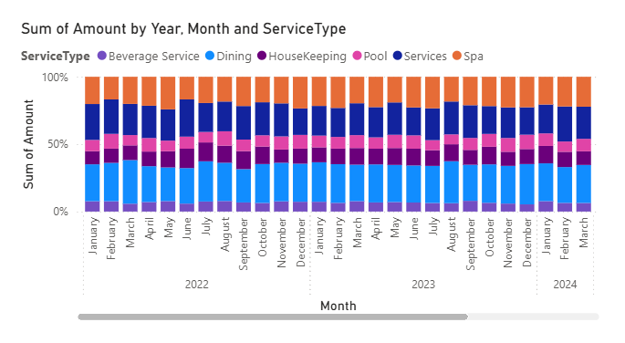
  - Insight: Identify if Spa usage peaks in winter or if Pool bar revenue peaks in summer.
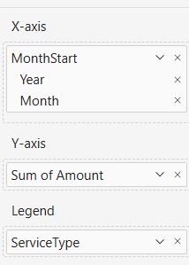
- Visual 2: Sum of Amount by ServiceType

  - Visual Type: Pie Chart
  - Legend: ServiceType
  - Values: Sum of Amount
  - Details: Displays percentage contribution of each service
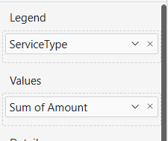
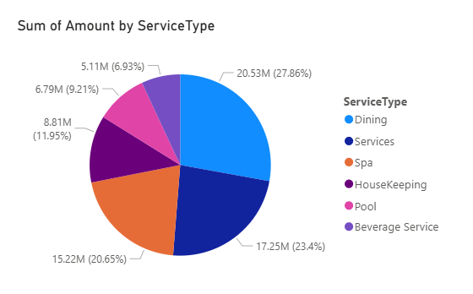

- Visual 3: Detailed Service Data Table (Bottom)

  - Visual Type: Matrix
  - Rows: ServiceType [ from Ancillary_Transactions]
  - Columns: Year
  - Values:
    - Sum of Amount
    - Count of TransID
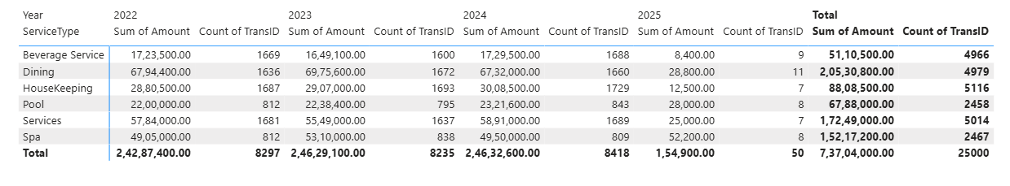
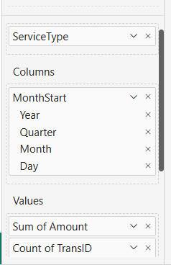

Page 2: Recommended Price Tiers

1. Pricing Tier Recommendations Matrix
- Visual Type: Matrix
- Rows: RoomType (Deluxe, Double, Executive, Single, Suite)
- Columns: Season (High, Low, Shoulder)
- Values: Recommended Price (This is the calculated DAX measure)
- Totals: Row and Column totals enabled.
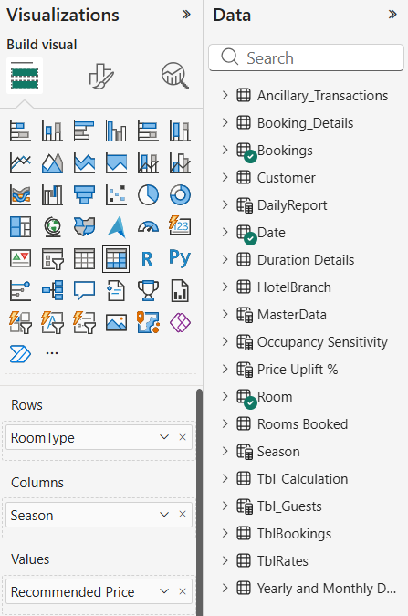
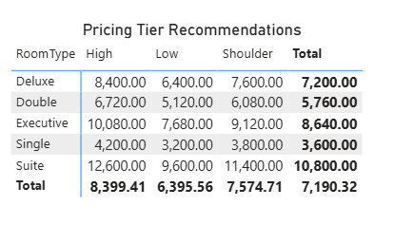

2. Interactive Parameters (Slicers)
- Visual Type: Slicer
- Slicer 1: Price Uplift % (Adjusts the Uplift variable in the price formula)
- Slicer 2: Occupancy Sensitivity (Adjusts the Elasticity variable in the price formula)

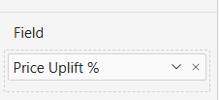
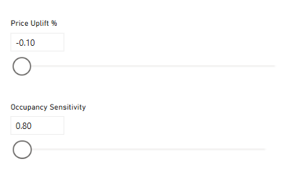

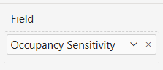

Page 3: General Manager (GM) Dashboard
1. KPI Headers
- Visual Type: Card
- Fields: Average of ADR, Average of RevPAR, Average of Occupancy %
2. Branch Benchmarking
- Visual Type: Line Chart (Categorical)
- X-Axis: BranchName (Bengaluru, Hyderabad, Chennai, Delhi, Mumbai)
- Y-Axis: Sum of Revenue
3. Weekly Trends
- Visual Type: Line Chart
- X-Axis: Week
- Y-Axis: Average of ADR, Average of RevPAR, Average of Occupancy %
4. Revenue Composition
- Visual Type: Pie Chart
- Legend: ServiceType
- Values: Sum of Amount (Revenue)
5. Appointment Status
- Visual Type: Pie Chart
- Legend: BookingStatus (Checked-in, No Show, Cancelled)
- Values: Count of Bookings
6. Future Occupancy
- Visual Type: Line Chart (with Forecast Area)
- X-Axis: Year / Date
- Y-Axis: Average of Occupancy %
7. Slicers
- Slicer 1: Week [ From tbl_Calculation]
- Slicer 2: Year, Quarter, Month [ From Ancillary_Transactions]
- Slicer 3: Gender [ from Customer table]

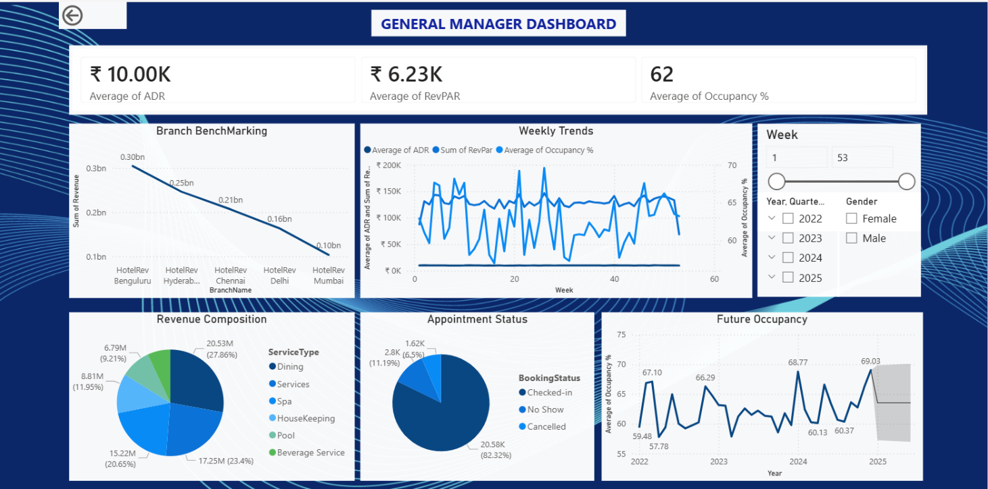
Page 4: Revenue Manager (RM) Dashboard
1. Pricing Tier Recommendations
- Visual Type: Matrix
- Rows: RoomType
- Columns: Season
- Values: Recommended Price
2. SpendScore vs FrequencyScore
- Visual Type: Scatter Plot
- X-Axis: Count of SpendScore
- Y-Axis: Sum of FrequencyScore
- Legend: CustomerCluster
3. Cancellation Rate
- Visual Type: Line Chart
- X-Axis: Year / Date
- Y-Axis: CancellationRate

4. Lead Time Distribution
- Visual Type: Clustered Bar Chart
- Y-Axis: LeadTime
- X-Axis: Count of BookingID
5. SourceType vs Visit Purpose
- Visual Type: Stacked Bar Chart
- Y-Axis: Purpose
- X-Axis: Count of BookingID
- Legend: SourceType (Direct, OTA)
6. Future Occupancy (Bottom Right)
- Visual Type: Line Chart (with Forecast)
- X-Axis: Year
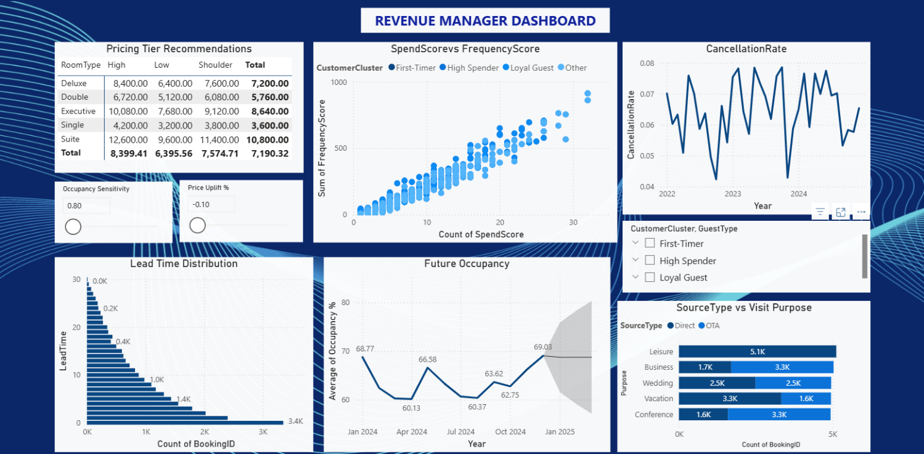
- Y-Axis: Average of Occupancy %

5. Key Insights
1. Revenue Diversification (Upsell Analytics)
- Dining is the Key Driver: The "Sum of Amount by ServiceType" pie chart indicates that Dining and Beverage Services constitute a significant portion of ancillary revenue.
- Service Seasonality: The stacked column chart shows that ancillary revenue fluctuates by month.
2. Pricing Precision (Dynamic Pricing Engine)
- Elasticity-Based Opportunity: The Recommended Price model incorporates an Occupancy Sensitivity parameter.
- Seasonal Tiering: The Matrix clearly defines the rate spread between High and Low seasons (e.g., Deluxe rooms drop from ~8,400 to ~6,400).
3. Customer Segmentation (RM Dashboard)
- The "Whales" vs. The "Masses": The SpendScore vs. FrequencyScore scatter plot identifies a specific cluster of "High Spenders" who visit frequently.
- Booking Behavior: The Lead Time Distribution shows a mix of very short lead times (0-5 days) and longer lead times.
4. Operational Efficiency (GM Dashboard)
- Branch Performance Gaps: The Branch Benchmarking chart highlights disparities between locations (e.g., Bengaluru vs. Mumbai).
- Staffing for Demand: The Future Occupancy forecast (with the grey confidence interval) allows the GM to align housekeeping rosters with predicted occupancy.
6. Conclusion:
By integrating Ancillary Transaction data with Bookings, the dashboard moves beyond simple RevPAR giving management a holistic view of guest value.
The implementation of the Dynamic Pricing Engine using DAX parameters (Price Uplift % and Occupancy Sensitivity) empowers the Revenue Manager to simulate market scenarios without altering raw data. This shifts the hotel's strategy from Reactive (looking at past spreadsheets) to Proactive (forecasting demand and adjusting prices in real-time).

